ECE 633 Individual Study Final Report
Goals:

- Understanding the Capacitive Touch Sensor
- Understanding the Touch Sensing Interface (TSI) module in KL25Z
- Implementing basic drivers for TSI module

Introduction:
In today’s generation of electronics, touch technology has been the driving force as it is found in most of the products. There are numerous devices and systems that incorporate Touch sensing technology. Basically, there are two types : resistive and capacitive touch sensing. Since, the report is based on capacitive touch sensing we will only discuss the capacitive technology only. The capacitive sensing techlogy has grown over the years and has beocome quite sophiticated but the underlying principle of sensing still remains the same. The capacitive touch sensing can be done using two methods : self capacitance configuration and mutual capacitance configuration.

Basics:

Mutual-Capacitance Configuration:
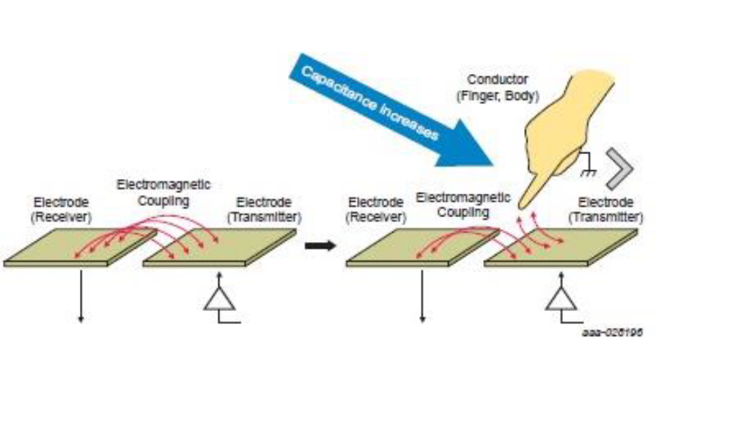

Fig.1

As shown in Fig. 1, there are two electrodes (transmitting and receiving) which are used to measure mutual capacitance. These electrodes are separated by the dielectric material which helps to form a capacitance. This capacitance creates an electromagnetic field which is sensed by the microcontroller. The microcontroller generates a pulse on the transmitting electrode which creates an electromagnetic field between the two electrodes. When a human finger comes in proximity, some of the electromagnetic field moves to the finger as it is conductive and thus it decreases the electromagnetic field between the electrodes which is sensed by the microcontroller. In KL25Z, there is no circuitry present for mutual capacitance. It only has self-capacitance configuration.

Self-Capacitance Configuration:

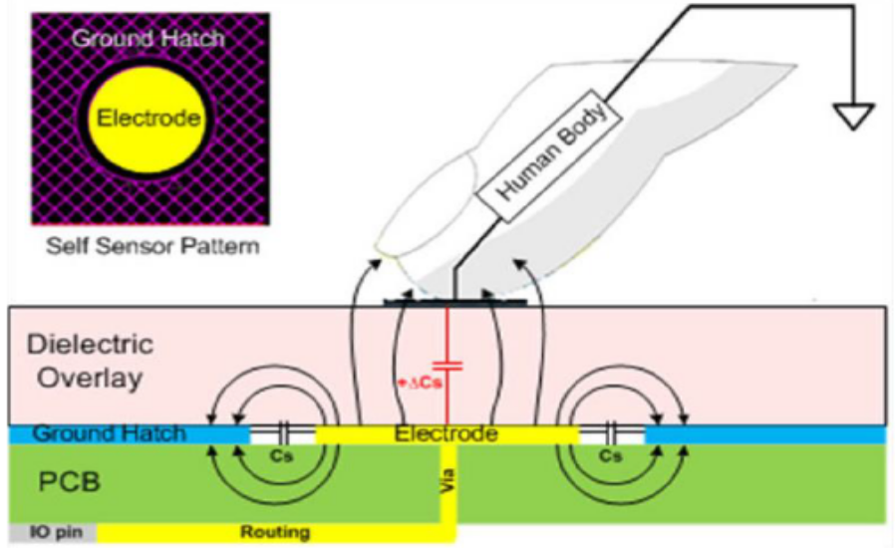

Fig. 2

As shown in Fig. 2, Self-capacitance works on single electrode principle. The capacitance is formed between the electrode and nearby ground plane. The internal circuit will drive that particular electrode and sense the charge and discharging time to measure the capacitance. When the finger comes in proximity of the electrode, there will be a change in electromagnetic field which will change the charge and discharge time, thereby changing the capacitance measured.

Implementation:
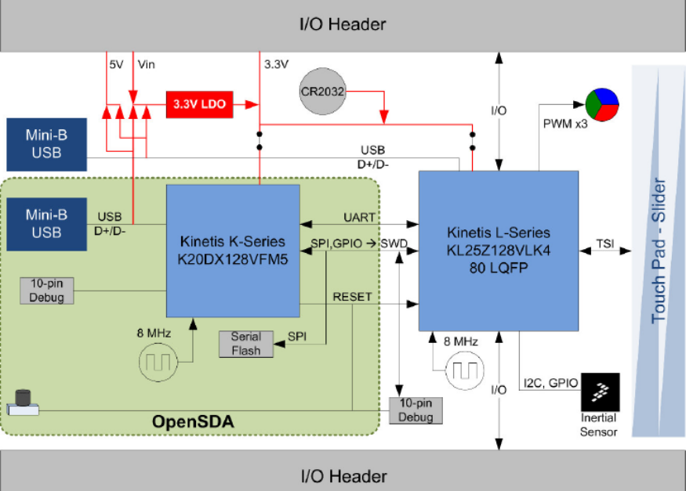

Fig. 3

The above Fig. 3 is the block diagram of FRDM KL25Z board which is used for the implementation of this project. Kindly note that there are a lot of other boards which are available from NXP which also has the TSI interface. The configuration remains the same. KL25Z supports only self- capacitance configuration. There are also some boards (e.g. KE15Z) which also supports mutual capacitance configuration.

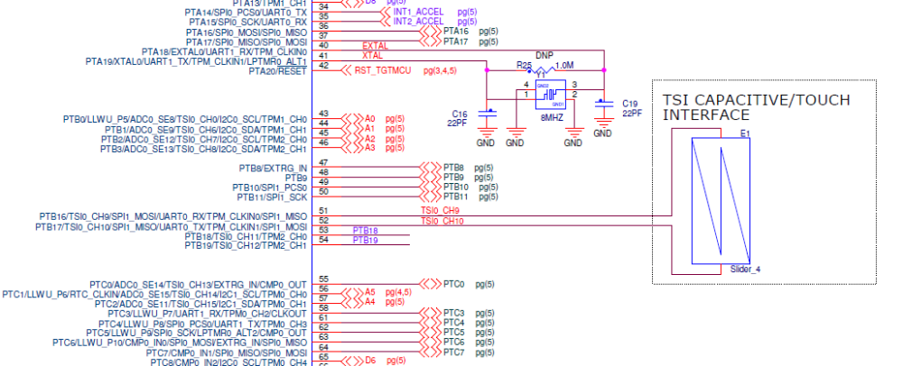

Fig. 4
The above Fig.4 shows the circuit diagram of FRDM KL25Z board. As seen in the figure, there is an analog slider which is connected to the Channel 9 and 10 of the TSI module. Since the controller only has self-capacitance mode, both the electrode needs to be sensed individually for getting the capacitance for each electrode. So, if you sense the capacitance of channel 10, the capacitance value would increase from left to right and right to left for channel 9.

TSI Module (KL 25Z) features:
- Support up to 16 external electrodes
- Configurable software or hardware scan trigger
- Capability to wake MCU from low power modes
- Support DMA data transfer

There are two ways of programming the TSI module:
- Using the TSS library. (Link in the reference section)
- Writing your own embedded drivers

In this project, drivers are written for busy-wait and interrupt-based design.

TSI module has three registers for configuration:
- General Control and Status Register (TSI0_GENCS)
- Threshold register (TSI0_TSHD)
- DATA register (TSI0_DATA)

General Control and Status Register (TSI0_GENCS):

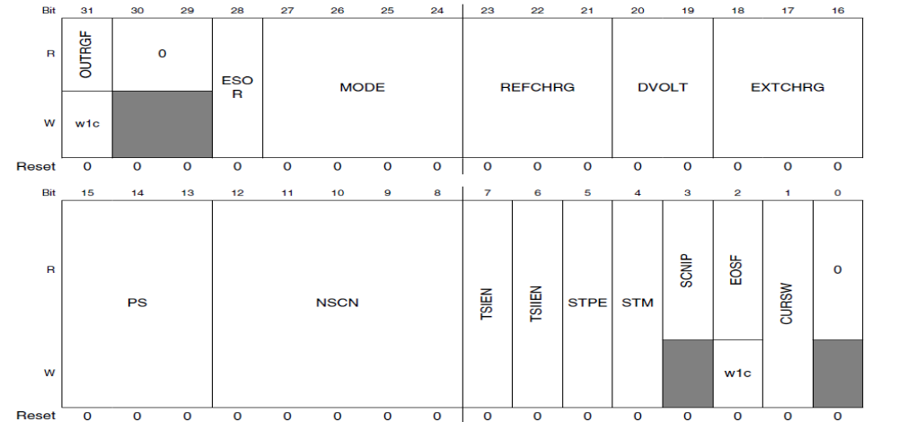

OUTRGF Out of range flag.
Set if result is out of range from the values in the Threshold register (TSHD).

ESOR End-of-scan or out-of-range interrupt selection.
0 = Interrupt on out-of-range
1 = Interrupt on end-of-scan

MODE Analog mode set up and status bits.
Four modes available.
Mode 0: non-noise mode.
Mode 1 and 2: Noise Threshold detection mode
Mode 3: Automatic Nosie detection mode

REFCHRG Reference oscillator charge/discharge value.
Eight values from 500 nA to 64uA available.

DVOLT Select oscillator voltage rails.
Four levels available.

EXTCHRG Electrode oscillator charge/discharge value.
Eight values from 500 nA to 64uA available.

PS Prescaler value.
Frequency divisor for clock can be from 1 to 128.

NSCN Electrode oscillator count used in making a scan.
Value can be from 1 to 32.

TSIEN TSI module enable.
0 = Module disabled
1 = Module enabled

TSIIEN TSI module interrupt enable.
0 = Interrupt disabled
1 = Interrupt enabled

STPE TSI STOP Enable.
Enables TSI module to operate in low-power modes.
0 = TSI disabled in low-power mode
1 = TSI runs in all low-power modes

STM Scan trigger mode.
0 = Software triggers scan
1 = Hardware clock triggers scan

SCNIP Scan in progress status.
0 = No scan in progress
1 = Scan in progress

EOSF End of scan flag.
0 = Scan incomplete
1 = Scan complete
Write 1 to clear this flag.

CURSW Current sources for oscillators swapped.
0 = Current source pair not swapped
1 = Current source pair swapped

Threshold register (TSI0_TSHD):

THRESH TSI wakeup channel high threshold value.
THRESL TSI wakeup channel low threshold value.

DATA register (TSI0_DATA):
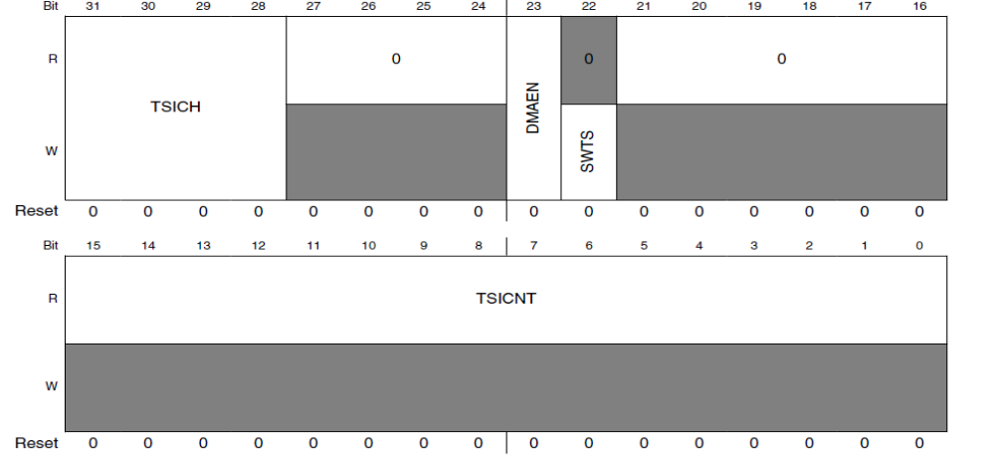

TSICH TSI channel select.
These bits select the channel to be sampled. The TSI supports a maximum of sixteen channels.

DMAEN DMA transfer enabled.
This bit determines whether the module generates a DMA request.

SWTS Software trigger start.
When this bit is set, the TSI starts a scan.
0 = No effect.
1 = Start a scan on the channel specified.

TSICNT TSI conversion counter value.
It is a measure of the electrode capacitance.

Code Implementation:
Kindly refer to the code which is shared along with the report. Kindly note that the code implements both Busy wait and interrupt-based system. It can be selected by changing the macro value. Comments have been added to the code for explanation.

Future Development:

- Interacting with different peripherals and using the TSI module along with it.
- Implementing the Interrupt using Threshold value.
- Implementing Multiple Interrupts using the both the electrodes.

References:

- https://www.allaboutcircuits.com/technical-articles/introduction-to-capacitive-touch-sensing/
- https://www.nxp.com/docs/en/user-guide/TSSUG.pdf
- https://www.nxp.com/docs/en/application-note/AN12082.pdf
- https://www.nxp.com/downloads/en/schematics/FRDM-KL25Z_SCH_REV_D.pdf
- https://www.nxp.com/docs/en/user-guide/KE15ZTSIUG.pdf
- https://www.nxp.com/docs/en/reference-manual/KL25P80M48SF0RM.pdf

